# Name : Adhiraj Nitin Budukh

# Email : [abudukh@wpi.edu](mailto:abudukh@wpi.edu)

# Tutorial 1 screenshots

2) Write and execute the following queries against the HMIS.db database: a. Count the number of hospital entities.

b. Count the instances of hospital entities in each state.

c. Count the instances of HMIS applications by application.

d. List the instances of status categories for the HMIS applications by HMIS application.

e. List the HMIS applications by city for hospitals in Massachusetts (MA).

Answers :

Reading the file :

Observations : took some time to read

Proof of creation :

a)

b)

c)

d)

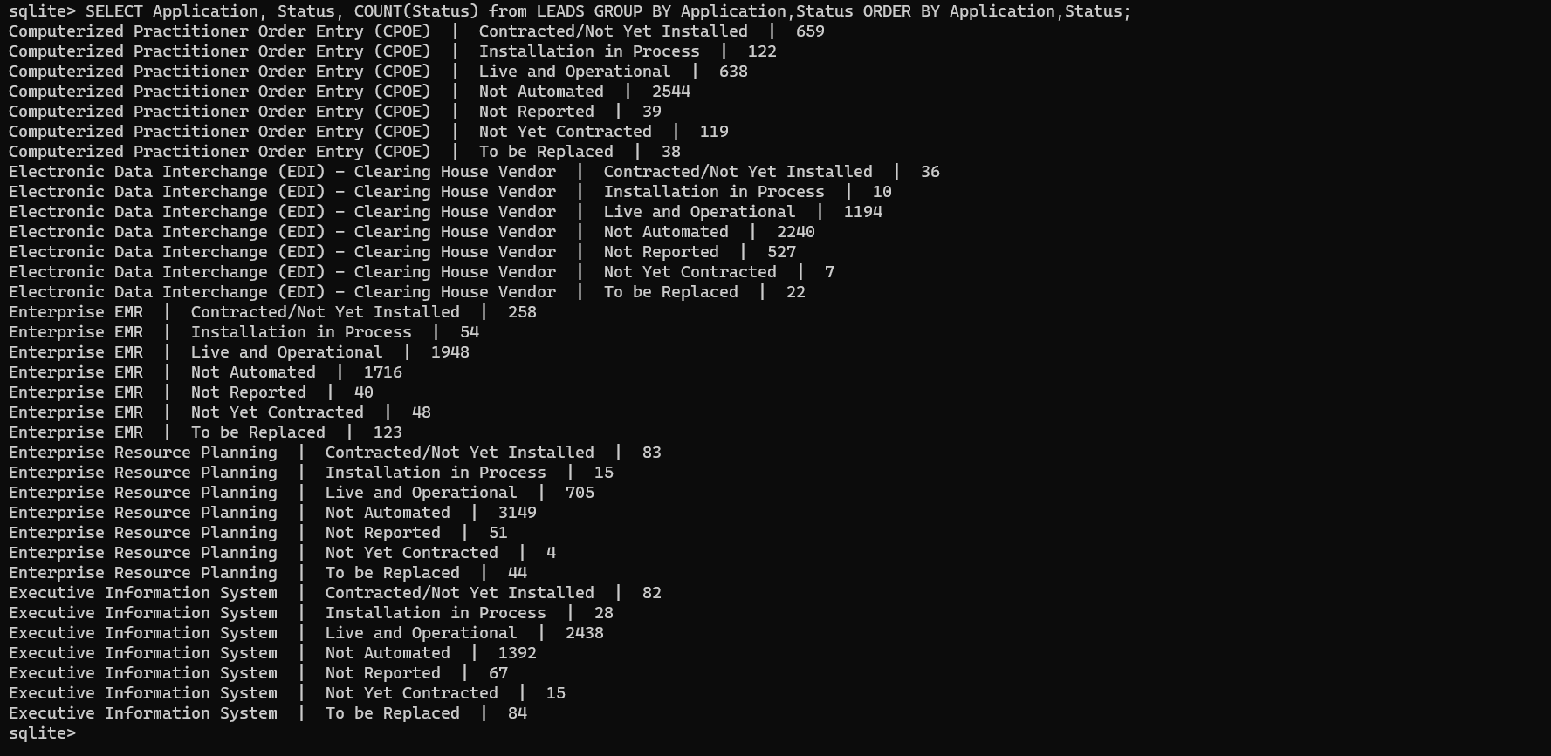

e)

